**Training and Attestation**

**Purpose**

The purpose of this document is to identify the training objectives completed, specific tasks completed, and attest that I completed the exercises utilizing my own understanding of the material.

**Exercise 2.9.2**

**Core**

1. Create connections.
   1. Connect proper cabling between Router0 and Cloud Eth6.
   2. Connect the Cloud Coax7 to Modem Port0.
   3. Connect Router0 to Router1.
   4. Connect Router0 to netacad.pka.
   5. Connect Router0 to the configuration terminal.
2. Verify connections.
3. Examine the Physical Topology

**Screenshots of Completion**

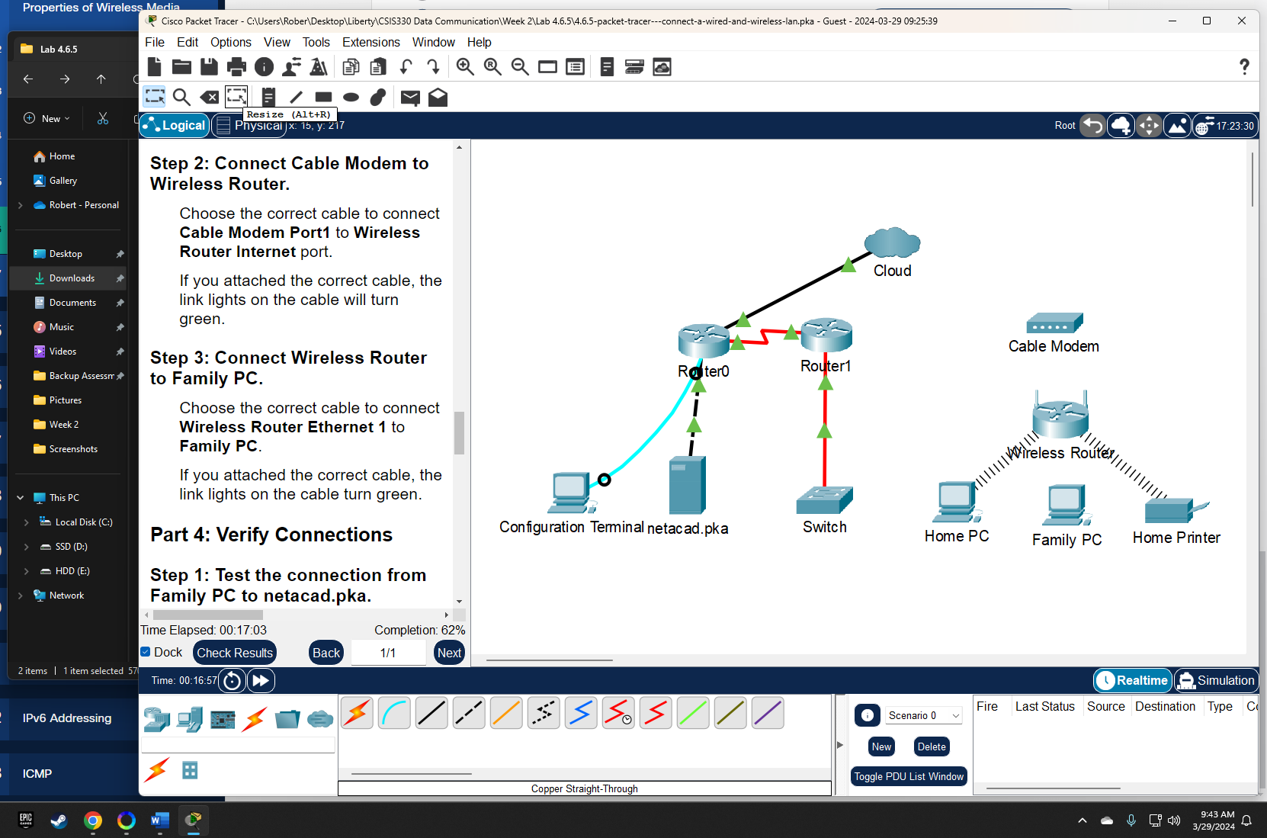

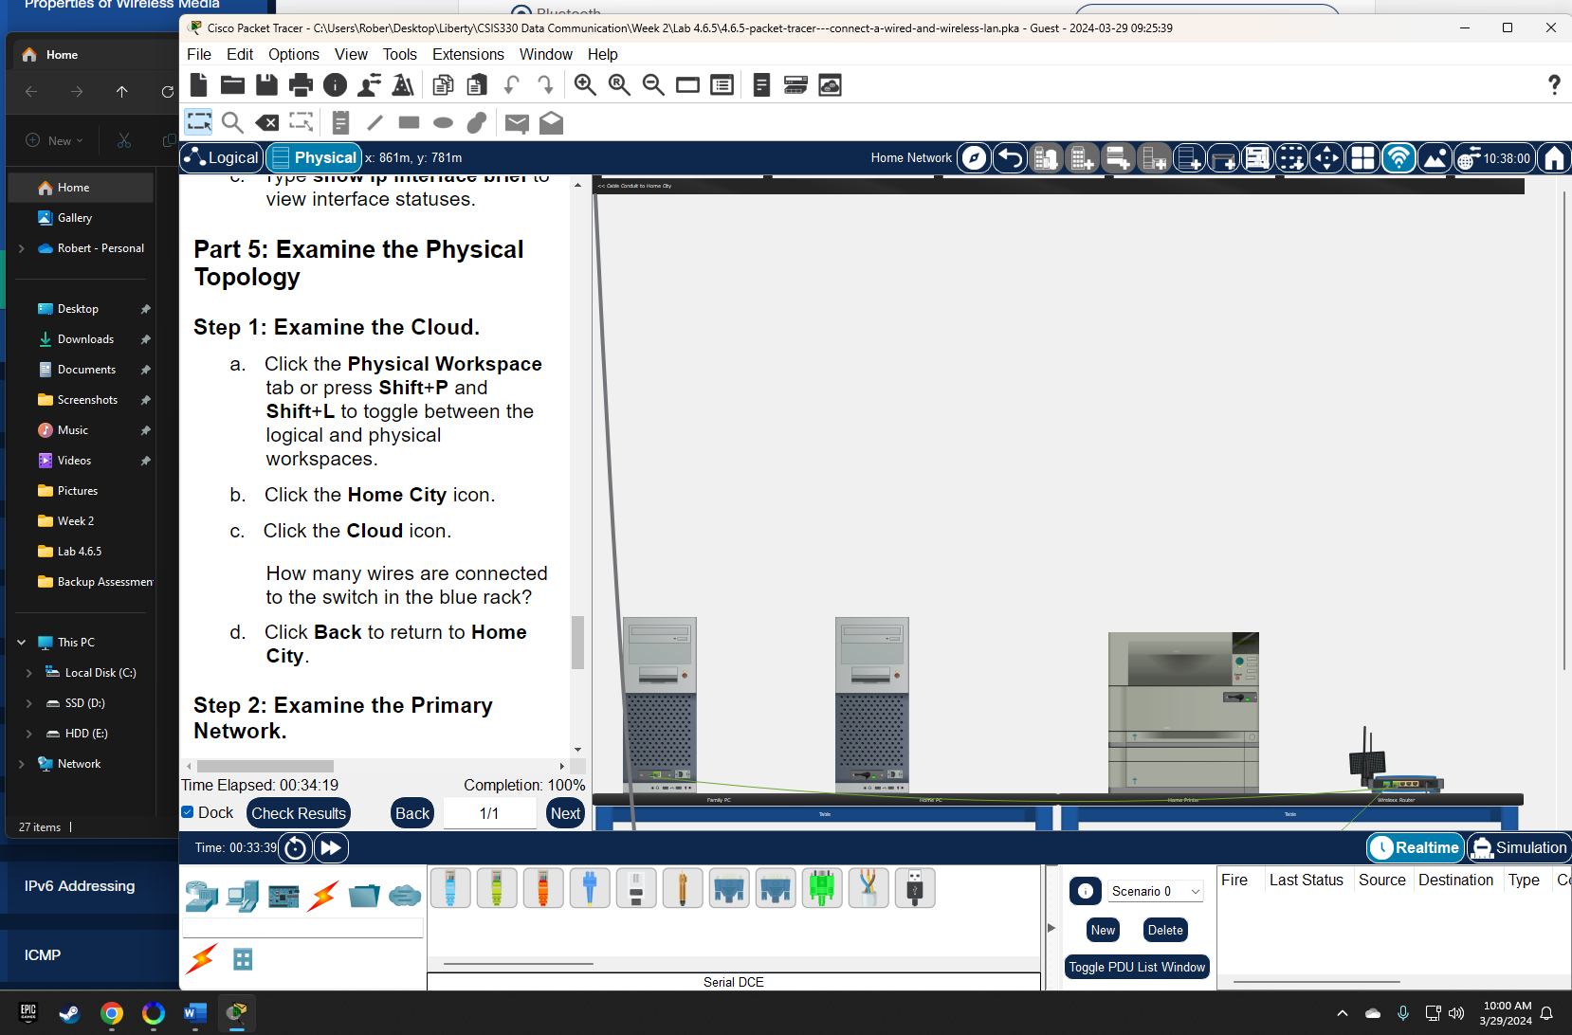

**Attestation**

I certify that I completed all the work required for this lab using the skills and knowledge gained from completing the Liberty University course work and Official Cisco CCNA training material. The answers were my own and I did not plagiarize anyone else’s work.

